**Questions:**

1. **With the help of the supplementary materials and demonstrated codes implement the variants of hill-climbing and genetic algorithms discussed above in Prolog and Python.**

**Solution to the question no. 1(a):**

**The demonstrated Prolog code of the Random restart hill climbing Algorithm is as below:**

:-use_module(eval_state).

:-use_module(list_apps).

:-dynamic(state/4). /* id,type,state,h_value*/

:-dynamic(id/1).

:-dynamic(max_val/1).

:-dynamic(threshold/1).

:-dynamic(restrt_cntr/1).

:-dynamic(list_st/1).

/* Organizing a Menu */

start:- repeat,

write('\n1. Clear database'),

write('\n2. Execute hcls'),

write('\n3. Display states'),

write('\n4. Save states'),

write('\n5. Exit'),

write('\n\nEnter your choice: '),

read(N), N >0, N < 6,

do(N), N=5,!.

do(1):- retractall(state(_,_,_,_)),retractall(id(_)), retractall(max_val(_)),

retractall(threshold(_)), retractall(restrt_cntr(_)).

do(2):- go_hcs.

do(3):- listing(state).

do(4):- write('Enter a new file name:'), read(Flnm),

tell(Flnm),listing(state),told.

do(5):- abort.

/* Beginning of search */

go_hcs:- write('Enter a state:'), read(S),

write('Enter threshold value:'), read(V),

assert(threshold(V)),assert(restrt_cntr(0)),

getdigits(S,D1,D2,D3,D4,D5,D6,D7,D8),

L=[D1,D2,D3,D4,D5,D6,D7,D8],

gnrt_sucsr(L).

/* Generating the successors of a 8-queens' state given as a list */

gnrt_sucsr(L):- assert(id(1)), assert(state(1,'c',L,50)),

incr_id, mk_new(1,L), retract(id(_)), evaluate.

incr_id:-id(V), V1 is V+1, retract(id(_)), assert(id(V1)).

mk_new(9,_):-!.

mk_new(N,L):- nthel(N,L,X), del_el(X,[1,2,3,4,5,6,7,8],L1),

cng_mk(N,L,L1), N1 is N+1, mk_new(N1,L).

cng_mk(_,_,[]):-!.

cng_mk(N,L,L1):- L1=[H|T], rplc_nthel(N,H,L,L2),id(Id),

assert(state(Id,'s',L2,50)), incr_id, cng_mk(N,L,T).

/* Evaluating the states */

evaluate:- eval_all, checkall.

eval_all:- state(I,T,L,_), eval(L,V),retract(state(I,_,_,_)),

assert(state(I,T,L,V)), fail.

eval_all:-!.

/* Determining and displaying the best state */

checkall:- state(_,'c',_,V1), threshold(V2), V1 >= V2, I is 1, dsply(I),!.

checkall:- best(I1,V1), threshold(V2), V1 >= V2, I is I1, dsply(I),!.

checkall:- state(_,'c',_,V1), best(I,V2) ,V2>V1,state(I,_,L,_),

retractall(state(_,_,_,_)),write_list(['\nIteration max: ',V2]),

gnrt_sucsr(L),!.

checkall:- rndm_restrt,!.

best(I,Max):- state(_,'s',_,Val), assert(max_val(Val)),

updt_max, max_val(Max), state(I,_,_,Max), retract(max_val(_)),!.

updt_max:- state(_,_,_,V2), max_val(V1), V2>V1,

retract(max_val(_)), assert(max_val(V2)), fail.

updt_max:-!.

dsply(I):-state(I,T,L,V),

write_list(['\n\nFound! Id:',I,' ',T,' ', L,' ','Value:',V,'\n']),!.

rndm_restrt:- retractall(state(_,_,_,_)), restrt_cntr(V), V<5,

write('\n\nStuckup! Restarting.\n\n'), restart,!.

rndm_restrt:-write('\n\nStuckup once again! Ending.\n\n').

restart:- incr_r_c, restrt_cntr(V), write_list(['\n\nRestart index: ',V]),

get_rndm_st(L),gnrt_sucsr(L).

incr_r_c:- restrt_cntr(V), V1 is V+1, retract(restrt_cntr(_)),

assert(restrt_cntr(V1)).

get_rndm_st(L):- assert(list_st([])), lp8(8), list_st(L), retract(list_st(_)).

lp8(0):-!.

lp8(N):- N1 is N-1, X is random(8)+1, list_st(L1),append(L1,[X],L2),

retract(list_st(L1)),assert(list_st(L2)),lp8(N1).

**A sample input and output is as below:**

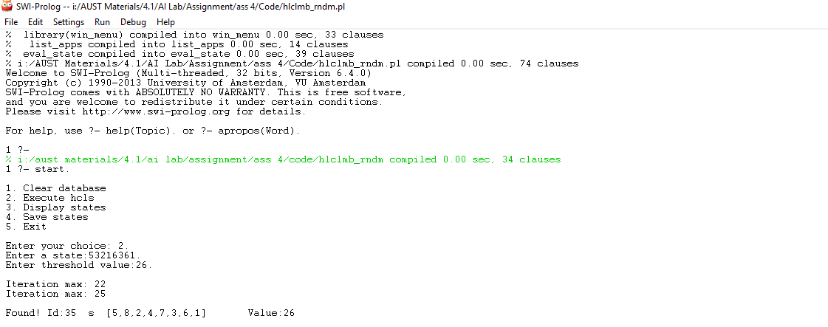

**The demonstrated Python code of the Random restart hill climbing Algorithm is as below:**

import random

threshold = 0

max_val = 0

restart_count = 0

states = []

max_id = 0

def clear_database():

global threshold

global max_val

global restart_count

global states

global max_id

threshold = 0

max_val = 0

restart_count = 0

states = []

max_id = 0

def execute_hcls():

global threshold

global states

state = input('enter a state: ')

threshold = int(input('enter threshold value: '))

L = list(state)

genarate_successor(L)

def display_states():

global states

for j in range(len(states)):

print(states[j])

def save_states():

global states

f1=open("std.py", "w")

for j in range(len(states)):

print(states[j],file = f1)

f1.close

def evalState(qList):

count = 0

#horizontal check

for i in range(0,len(qList),1):

for j in range(i+1,len(qList),1):

if (qList[i] == qList[j]):

count = count + 1

#diagonal_up check

for i in range(0,len(qList),1):

x = int(qList[i])

for j in range(i+1,len(qList),1):

x = x + 1

if (x == int(qList[j])):

count = count + 1

#diagonal_down check

for i in range(0,len(qList),1):

x = int(qList[i])

for j in range(i+1,len(qList),1):

x = x - 1

if (x == int(qList[j])):

count = count + 1

return count

def eval(L):

return 28 - evalState(L)

def genarate_successor(L):

global threshold

global max_val

global restart_count

global states

global max_id

hval = eval(L)

y = [1,'c',L,hval]

#print(y)

stuck = True

max_val = hval

max_id = 1

states = []

states.append(y)

idcount = 2

for i in range(1,9):

for j in range(1,9):

if(L[i-1] != str(j)):

x = L[:]

x[i-1] = str(j)

hval = eval(x)

y = [idcount,'s',x,hval]

states.append(y)

if(max_val < hval):

max_val = hval

max_id = idcount

#print(max_val,end =' ')

#print(max_id)

stuck = False

idcount += 1

checkall(stuck)

def checkall(stuck):

global threshold

global max_val

global restart_count

global states

global max_id

if max_val >= threshold:

print('found! '+str(states[max_id - 1]))

elif(restart_count >= 5):

print('Stuckup Again! Stop..\n ')

elif stuck == True and restart_count < 5:

print('Stuckup! Restarting..\n ')

restart_count += 1

genarate_successor(randomState())

elif max_val < threshold :

print('iteration max: '+str(max_val))

genarate_successor(states[max_id - 1][2])

def randomState():

rstate = []

for x in range(8):

val = str(random.randint(1,9))

rstate.append(val)

return rstate

#Main

cs = 1

while(cs>=1 and cs<5):

print('\n1. Clear database')

print('\n2. Execute hcls')

print('\n3. Display states')

print('\n4. Save states')

print('\n5. Exit')

cs = int(input('\n\nEnter your choice: '))

if(cs == 1):

clear_database()

elif(cs == 2):

execute_hcls()

elif(cs == 3):

display_states()

elif(cs == 4):

save_states()

else:

break

**A sample input and output is as below:**

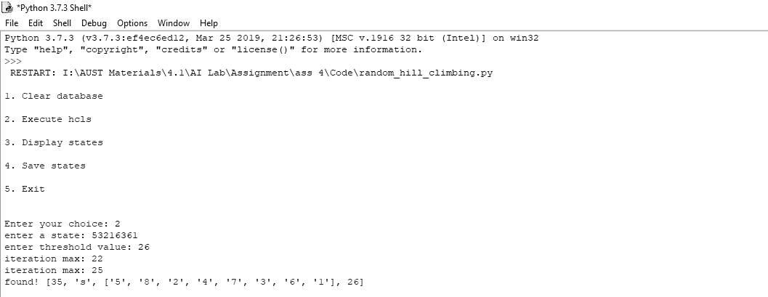

**Solution to the question no. 1(b):**

**The demonstrated Prolog code of the Stochastic Hill-climbing Algorithm is as below:**

:-use_module(eval_state).

:-use_module(list_apps).

:-dynamic(state/4). /* id,type,state,h_value*/

:-dynamic(id/1).

:-dynamic(max_val/1).

:-dynamic(threshold/1).

:-dynamic(restrt_cntr/1).

:-dynamic(list_st/1).

/* Organizing a Menu */

start:- repeat,

write('\n1. Clear database'),

write('\n2. Execute hcls'),

write('\n3. Display states'),

write('\n4. Save states'),

write('\n5. Exit'),

write('\n\nEnter your choice: '),

read(N), N >0, N < 6,

do(N), N=5,!.

do(1):- retractall(state(_,_,_,_)),retractall(id(_)), retractall(max_val(_)),

retractall(threshold(_)), retractall(restrt_cntr(_)).

do(2):- go_hcs.

do(3):- listing(state).

do(4):- write('Enter a new file name:'), read(Flnm),

tell(Flnm),listing(state),told.

do(5):- abort.

/* Beginning of search */

go_hcs:- write('Enter a state:'), read(S),

write('Enter threshold value:'), read(V),

assert(threshold(V)),assert(restrt_cntr(0)),

getdigits(S,D1,D2,D3,D4,D5,D6,D7,D8),

L=[D1,D2,D3,D4,D5,D6,D7,D8],

gnrt_sucsr(L).

/* Generating the successors of a 8-queens' state given as a list */

gnrt_sucsr(L):- assert(id(1)), assert(state(1,'c',L,50)),

incr_id, mk_new(1,L), retract(id(_)), evaluate.

incr_id:-id(V), V1 is V+1, retract(id(_)), assert(id(V1)).

mk_new(9,_):-!.

mk_new(N,L):- nthel(N,L,X), del_el(X,[1,2,3,4,5,6,7,8],L1),

cng_mk(N,L,L1), N1 is N+1, mk_new(N1,L).

cng_mk(_,_,[]):-!.

cng_mk(N,L,L1):- L1=[H|T], rplc_nthel(N,H,L,L2),id(Id),

assert(state(Id,'s',L2,50)), incr_id, cng_mk(N,L,T).

/* Evaluating the states */

evaluate:- eval_all,plist.

eval_all:- state(I,T,L,_), eval(L,V),retract(state(I,_,_,_)),

assert(state(I,T,L,V)), fail.

eval_all:-!.

dsply(I):-state(I,T,L,V),

write_list(['\n\nFound! Id:',I,' ',T,' ', L,' ','Value:',V,'\n']),!.

plist:- state(_,'c',_,V1), threshold(V2), V1 >= V2, I is 1, dsply(I),!.

plist:- best(I1,V1), threshold(V2), V1 >= V2, I is I1, dsply(I),!.

plist:-state(_,c,_,V),state(I1,s,L,V1),V1>V,retractall(state(_,_,_,_)),

X is random(2)+1, X>1,assert(list_st([L])), write('Random Uphill: ') ,write_list([I1,' ',L,' ',V1]),nl, gnrt_sucsr(L), !.

plist:- rndm_restrt,!.

best(I,Max):- state(_,'s',_,Val), assert(max_val(Val)),

updt_max, max_val(Max), state(I,_,_,Max), retract(max_val(_)),!.

updt_max:- state(_,_,_,V2), max_val(V1), V2>V1,

retract(max_val(_)), assert(max_val(V2)), fail.

updt_max:-!.

rndm_restrt:- retractall(state(_,_,_,_)), write('\n\nStuckup! Restart.\n\n').

**A sample input and output is as below:**

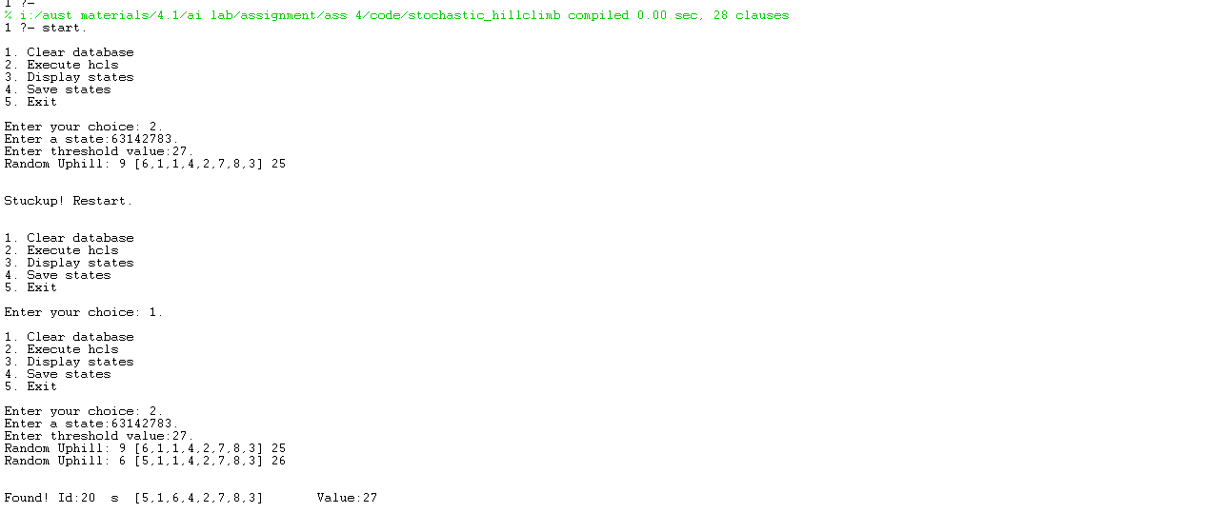

**The demonstrated Python code of the Stochastic Hill-climbing Algorithm is as below:**

import random

threshold = 0

max_val = 0

restart_count = 0

states = []

max_id = 0

def clear_database():

global threshold

global max_val

global restart_count

global states

global max_id

threshold = 0

max_val = 0

restart_count = 0

states = []

max_id = 0

def execute_hcls():

global threshold

global states

state = input('enter a state: ')

threshold = int(input('enter threshold value: '))

L = list(state)

genarate_successor(L)

def display_states():

global states

for j in range(len(states)):

print(states[j])

def save_states():

global states

f1=open("std.py", "w")

for j in range(len(states)):

print(states[j],file = f1)

f1.close

def evalState(qList):

count = 0

#horizontal check

for i in range(0,len(qList),1):

for j in range(i+1,len(qList),1):

if (qList[i] == qList[j]):

count = count + 1

#diagonal_up check

for i in range(0,len(qList),1):

x = int(qList[i])

for j in range(i+1,len(qList),1):

x = x + 1

if (x == int(qList[j])):

count = count + 1

#diagonal_down check

for i in range(0,len(qList),1):

x = int(qList[i])

for j in range(i+1,len(qList),1):

x = x - 1

if (x == int(qList[j])):

count = count + 1

return count

def eval(L):

return 28 - evalState(L)

def genarate_successor(L):

global threshold

global max_val

global restart_count

global states

global max_id

isFound = False

hval = eval(L)

y = [1,'c',L,hval]

#print(y)

stuck = True

max_val = hval

max_id = 1

states = []

states.append(y)

if max_val >= threshold:

isFound = True

checkall(stuck)

if isFound == False:

idcount = 2

uphills = []

for i in range(1,9):

for j in range(1,9):

if(L[i-1] != str(j)):

x = L[:]

x[i-1] = str(j)

hval = eval(x)

y = [idcount,'s',x,hval]

states.append(y)

if(max_val < hval):

uphills.append(idcount)

stuck = False

idcount += 1

if(stuck == False and len(uphills)>0):

uid = random.randint(1,len(uphills)) - 1

max_id = uphills[ uid ]

max_val = states[uid - 1][3]

checkall(stuck)

def checkall(stuck):

global threshold

global max_val

global restart_count

global states

global max_id

if max_val >= threshold:

print('found! '+str(states[max_id - 1]))

elif stuck == True:

print('Stuckup!\n ')

elif max_val < threshold :

print('Selected Uphill: '+str(states[max_id - 1]))

genarate_successor(states[max_id - 1][2])

#Main

cs = 1

while(cs>=1 and cs<5):

print('\n1. Clear database')

print('\n2. Execute hcls')

print('\n3. Display states')

print('\n4. Save states')

print('\n5. Exit')

cs = int(input('\n\nEnter your choice: '))

if(cs == 1):

clear_database()

elif(cs == 2):

execute_hcls()

elif(cs == 3):

display_states()

elif(cs == 4):

save_states()

else:

break

**A sample input and output is as below:**

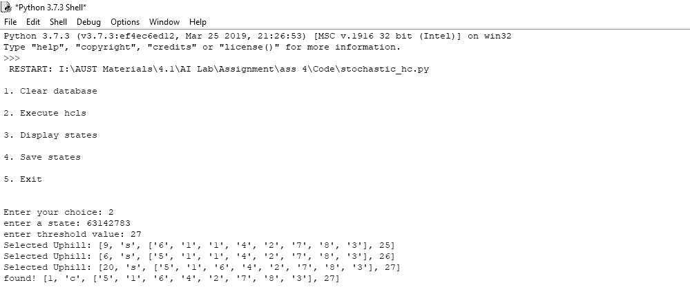

**Solution to the question no. 1(c):**

**The demonstrated Prolog code of the Simulated annealing Algorithm is as below:**

:-use_module(eval_state).

:-use_module(list_apps).

:-dynamic(state/4). /* id,type,state,h_value*/

:-dynamic(id/1).

:-dynamic(max_val/1).

:-dynamic(threshold/1).

:-dynamic(restrt_cntr/1).

:-dynamic(list_st/1).

/* Organizing a Menu */

start:- repeat,

write('\n1. Clear database'),

write('\n2. Execute hcls'),

write('\n3. Display states'),

write('\n4. Save states'),

write('\n5. Exit'),

write('\n\nEnter your choice: '),

read(N), N >0, N < 6,

do(N), N=5,!.

do(1):- retractall(state(_,_,_,_)),retractall(id(_)), retractall(max_val(_)),

retractall(threshold(_)), retractall(restrt_cntr(_)).

do(2):- go_hcs.

do(3):- listing(state).

do(4):- write('Enter a new file name:'), read(Flnm),

tell(Flnm),listing(state),told.

do(5):- abort.

/* Beginning of search */

go_hcs:- write('Enter a state:'), read(S),

write('Enter threshold value:'), read(V),

assert(threshold(V)),assert(restrt_cntr(0)),

getdigits(S,D1,D2,D3,D4,D5,D6,D7,D8),

L=[D1,D2,D3,D4,D5,D6,D7,D8],

gnrt_sucsr(L).

/* Generating the successors of a 8-queens' state given as a list */

gnrt_sucsr(L):- assert(id(1)), assert(state(1,'c',L,50)),

incr_id, mk_new(1,L), retract(id(_)), evaluate.

incr_id:-id(V), V1 is V+1, retract(id(_)), assert(id(V1)).

mk_new(9,_):-!.

mk_new(N,L):- nthel(N,L,X), del_el(X,[1,2,3,4,5,6,7,8],L1),

cng_mk(N,L,L1), N1 is N+1, mk_new(N1,L).

cng_mk(_,_,[]):-!.

cng_mk(N,L,L1):- L1=[H|T], rplc_nthel(N,H,L,L2),id(Id),

assert(state(Id,'s',L2,50)), incr_id, cng_mk(N,L,T).

/* Evaluating the states */

evaluate:- eval_all,checkall.

eval_all:- state(I,T,L,_), eval(L,V),retract(state(I,_,_,_)),

assert(state(I,T,L,V)), fail.

eval_all:-!.

dsply(I):-state(I,T,L,V),

write_list(['\n\nFound! Id:',I,' ',T,' ', L,' ','Value:',V,'\n']),!.

checkall:- state(_,'c',_,V1), threshold(V2), V1 >= V2, I is 1, dsply(I),!.

checkall:- best(I1,V1), threshold(V2), V1 >= V2, I is I1, dsply(I),!.

checkall:- incr_c, divideBy(X1),not(X1=0), state(_,c,_,V),state(I1,s,L,V1),V1>V, retractall(state(_,_,_,_)),

X is random(2)+1, X>1 ,assert(list_st([L])), write('Random Uphill Successor : ') ,write_list([I1,' ',L,' ',V1]),nl, gnrt_sucsr(L), !.

checkall:- divideBy(X1), X1=0 , state(_,c,_,V),state(I1,s,L,V1), V1<V, retractall(state(_,_,_,_)),

X is random(2)+1, X>1 ,assert(list_st([L])), write('Random Downhill Successor : ') ,write_list([I1,' ',L,' ',V1]),nl, gnrt_sucsr(L), !.

checkall:- rndm_restrt,!.

best(I,Max):- state(_,'s',_,Val), assert(max_val(Val)),

updt_max, max_val(Max), state(I,_,_,Max), retract(max_val(_)),!.

updt_max:- state(_,_,_,V2), max_val(V1), V2>V1,

retract(max_val(_)), assert(max_val(V2)), fail.

updt_max:-!.

rndm_restrt:- retractall(state(_,_,_,_)), write('\n\nStuckup! Restart.\n\n').

incr_c:- restrt_cntr(V), V1 is V+1, retract(restrt_cntr(_)),

assert(restrt_cntr(V1)).

divideBy(X1) :- restrt_cntr(V), X1 is V mod 5,!.

**A sample input and output is as below:**

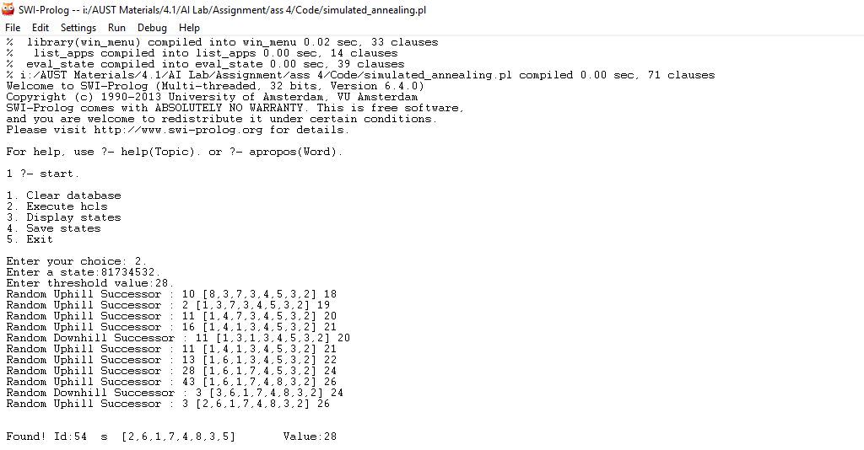

**The demonstrated Python code of the Simulated annealing Algorithm is as below:**

import random

threshold = 0

max_val = 0

counter = 1

states = []

max_id = 0

def clear_database():

global threshold

global max_val

global counter

global states

global max_id

threshold = 0

max_val = 0

counter = 1

states = []

max_id = 0

def execute_hcls():

global threshold

global states

state = input('enter a state: ')

threshold = int(input('enter threshold value: '))

L = list(state)

genarate_successor(L)

def display_states():

global states

for j in range(len(states)):

print(states[j])

def save_states():

global states

f1=open("std.py", "w")

for j in range(len(states)):

print(states[j],file = f1)

f1.close

def evalState(qList):

count = 0

#horizontal check

for i in range(0,len(qList),1):

for j in range(i+1,len(qList),1):

if (qList[i] == qList[j]):

count = count + 1

#diagonal_up check

for i in range(0,len(qList),1):

x = int(qList[i])

for j in range(i+1,len(qList),1):

x = x + 1

if (x == int(qList[j])):

count = count + 1

#diagonal_down check

for i in range(0,len(qList),1):

x = int(qList[i])

for j in range(i+1,len(qList),1):

x = x - 1

if (x == int(qList[j])):

count = count + 1

return count

def eval(L):

return 28 - evalState(L)

def genarate_successor(L):

global threshold

global max_val

global counter

global states

global max_id

isFound = False

hval = eval(L)

y = [1,'c',L,hval]

#print(y)

stuck = True

max_val = hval

max_id = 1

states = []

states.append(y)

if max_val >= threshold:

isFound = True

checkall(stuck)

if isFound == False:

idcount = 2

uphills = []

for i in range(1,9):

for j in range(1,9):

if(L[i-1] != str(j)):

x = L[:]

x[i-1] = str(j)

hval = eval(x)

y = [idcount,'s',x,hval]

states.append(y)

if(divideBy(counter) != 0 and max_val < hval):

uphills.append(idcount)

stuck = False

elif(divideBy(counter) == 0 and max_val > hval):

uphills.append(idcount)

stuck = False

idcount += 1

if(stuck == False and len(uphills)>0):

uid = random.randint(1,len(uphills)) - 1

max_id = uphills[ uid ]

max_val = states[uid - 1][3]

checkall(stuck)

def checkall(stuck):

global threshold

global max_val

global counter

global states

global max_id

#print('counter : '+str(counter))

if max_val >= threshold:

print('found! '+str(states[max_id - 1]))

elif stuck == True:

print('Stuckup!\n ')

elif max_val < threshold and stuck == False :

if divideBy(counter) != 0:

print('Selected Uphill: '+str(states[max_id - 1]))

counter += 1

genarate_successor(states[max_id - 1][2])

else:

print('Selected Downhill: '+str(states[max_id - 1]))

counter += 1

genarate_successor(states[max_id - 1][2])

def divideBy(x):

return x % 5

#Main

cs = 1

while(cs>=1 and cs<5):

print('\n1. Clear database')

print('\n2. Execute hcls')

print('\n3. Display states')

print('\n4. Save states')

print('\n5. Exit')

cs = int(input('\n\nEnter your choice: '))

if(cs == 1):

clear_database()

elif(cs == 2):

execute_hcls()

elif(cs == 3):

display_states()

elif(cs == 4):

save_states()

else:

break

**A sample input and output is as below:**

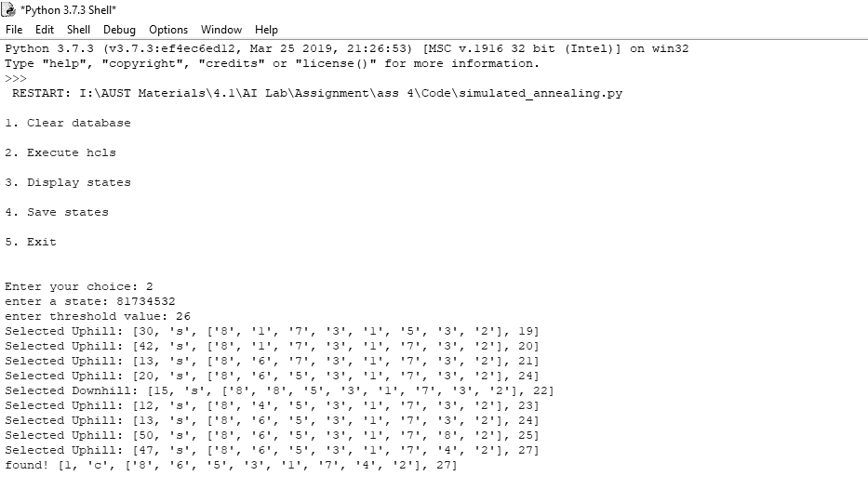

**Solution to the question no. 1(d):**

**The demonstrated Python code of the Genetic Algorithm is as below:**

import random

threshold = 0

max_val = 0

restart_count = 0

states = []

max_id = 0

def clear_database():

global threshold

global max_val

global restart_count

global states

global max_id

threshold = 0

max_val = 0

restart_count = 0

states = []

max_id = 0

def execute_hcls():

global threshold

global states

n = input('How many parent generation: ')

for i in range(int(n)):

state = input('enter state '+str(i+1)+' : ')

L = list(state)

states.append(L)

threshold = int(input('enter threshold value: '))

makeParents()

def display_states():

global states

for j in range(len(states)):

print(states[j])

def save_states():

global states

f1=open("std.py", "w")

for j in range(len(states)):

print(states[j],file = f1)

f1.close

def evalState(qList):

count = 0

#horizontal check

for i in range(0,len(qList),1):

for j in range(i+1,len(qList),1):

if (qList[i] == qList[j]):

count = count + 1

#diagonal_up check

for i in range(0,len(qList),1):

x = int(qList[i])

for j in range(i+1,len(qList),1):

x = x + 1

if (x == int(qList[j])):

count = count + 1

#diagonal_down check

for i in range(0,len(qList),1):

x = int(qList[i])

for j in range(i+1,len(qList),1):

x = x - 1

if (x == int(qList[j])):

count = count + 1

return count

def eval(L):

return 28 - evalState(L)

def makeParents():

global states

global threshold

maxValue = 0

maxState = []

isFound = False

stuck = False

i = 0

while i < len(states):

if eval(states[i]) >= threshold:

maxState = states[i]

maxValue = eval(states[i])

isFound = True

break

elif eval(states[i]) < 15:

states.remove(states[i])

else:

maxValue = max(maxValue, eval(states[i]))

i += 1

if len(states) == 0:

stuck = True

#Chossing parents randomly for crossover

if isFound == False and stuck == False:

"""

print('Parent Generations: \n')

for i in range( len(states) ):

print(states[i])

"""

x = random.randint(0,len(states)-1)

while True:

y = random.randint(0,len(states)-1)

if(y != x):

break

parent1 = states[x]

parent2 = states[y]

crossover(parent1, parent2)

if isFound == True:

print('Found! '+str(maxState)+' '+str(maxValue))

elif stuck == True:

print('Stuck! ')

else:

print('Iteration Max: '+str(maxValue))

makeParents()

def crossover(parent1, parent2):

global states

crossoverPoint = random.randint(0,8)

offSpring1 = []

offSpring2 = []

offSpring1[: crossoverPoint] = parent1[ :crossoverPoint ]

offSpring1[crossoverPoint: ] = parent2[crossoverPoint : ]

offSpring2[: crossoverPoint] = parent2[ :crossoverPoint ]

offSpring2[crossoverPoint: ] = parent1[crossoverPoint : ]

#Mutation

if random.randint(0,10) > 7:

x = random.randint(0,7)

offSpring1[x] = str(random.randint(1,8))

states.append(offSpring1)

states.append(offSpring2)

#Main

cs = 1

while(cs>=1 and cs<5):

print('\n1. Clear database')

print('\n2. Execute hcls')

print('\n3. Display states')

print('\n4. Save states')

print('\n5. Exit')

cs = int(input('\n\nEnter your choice: '))

if(cs == 1):

clear_database()

elif(cs == 2):

execute_hcls()

elif(cs == 3):

display_states()

elif(cs == 4):

save_states()

else:

break

**A sample input and output is as below:**

